Church Calendar

Today Power House Prayer 9:30 am
Sabbath School 10:00 am
Worship Service 11:00 am
Next Sabbath Power House Prayer 9:30 am
Sabbath School 10:00 am
Worship Service 11:00 am

Sunset Today 7:24 pm Next Sabbath 7:31 pm

Church Clerks: Stacy Colley 573-933-0146

Church Treasurer: Nathan Crouch 573-819-9008
colsda.ap@gmail.com

Church Board Chairman: Joe Parmele 402-499-3750
joeparmele@gmail.com

Bulletin Coordinator: Abigail Olajire 573-476-2296
abigailolajire@gmail.com

College Park Christian Academy 573-445-6315
office@cpchristian.org
www.cpchristian.com

School Principal: Sandra Blackburn
principal@cpchristian.org

College Park Christian Preschool 573-445-3418
www.cpcprek.com
Preschool Director: Ami Hayse 573-424-7690

Pastoral Team:
Lead Pastor: Dr. Hiram Rester 417-848-7650
Head Elder: Joe Parmele--------- (J-P) 402-499-3750
Yaw Adu-Gyamfi -----------------(Q-Z) 302-883-7460
Joseph Bieksza --------------------(A-C) 573-544-3792
Aggrey Wanyonyi-----------------(Hope) 573-446-4112

Please have all bulletin information to the bulletin coordinator by Wednesday evening. To have a platform announcement made call the elder on duty by Friday.

Please send all audio/video requests for Sabbath to colsdaav@gmail.com by noon on Friday. For other days send requests in at least 48 hours before the event.

Morning Devotion Line:
6:00 to 6:30 am call: 1-712-770-4874 access code 558690#
To hear recorded call: 1-712-770-5434 access code 558690#

For Your Information: If you would like to view the Livestream of the service or see the bulletin online, please go to the church website: http://columbiasdachurch.com

College Park Seventh-day Adventist Church

1100 College Park Drive

PO Box 30802

Columbia, MO 65205

573-445-2712

College Park
Seventh-day Adventist Church

Our Mission: Serve Others, Share Christ
and Develop Disciples.

March 23, 2024

Church at Study
10:00 am

Sabbath School CPCA Gym
Refresh CPCA Chapel
Cradle Roll Room – Birth through 3 years Lower Level
Primary Room – 4 through 7 years Lower Level
Junior Room– 8 years through 12 years Lower Level
Youth – 13 years and up CPCA School classroom

Church at Worship
11:00 am

Prelude Emilie Dye-Howard

Worship in Music Praise Team

Welcome Pastor Hiram Rester

Announcements, Offering & Prayer Matt Howard
Today's Offering is for Combined Youth Ministries.
All loose offering goes to local church expense.
March 30th offering is for Local Church Budget. Thanks for prayerfully considering what God would have you give.

Special Music Steven Blackburn

Worship in Word Pastor Hiram Rester

Closing Prayer Pastor Hiram Rester

Praise Team Leader Emilie Dye-Howard

Postlude Emilie Dye-Howard

Announcements

Welcome to the College Park Seventh-day Adventist Church. We are so glad you chose to worship with us this Sabbath.

March Book of the Month: The Everlasting Relevance of the Sabbath unpacks the rich prophetic significance and moral implications of the seventh-day Sabbath as a memorial of Creation and God's gift of holy time to humanity. Learn more about this book at www.adventistbookcenter.com and don't forget to use your church code 53025.

Amazing Facts is coming to Sunnydale church! Friday evening, May 3; all day Sabbath May 4 and Sunday morning May 5. Amazing Facts Center for Evangelism will have two presenters to teach evangelism that works in 2024. Spread the word as we want to have as many participants as possible. Soon, we will have an email registration so we can order the materials for those planning to attend. Doug Erickson (573) 745-1717 is the contact for more information.

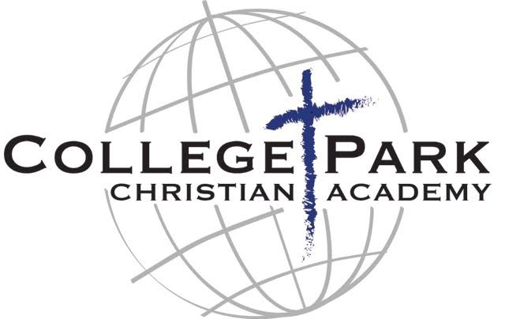

Registration for the 2024-2025 school year is now open! If you know of a student who would like to attend our school, please contact the school office at 573-445-6315 for more information.

Thank you! We are so thankful for our church family who generously contributed to our matching funds fundraiser! We were able to get the full matching grant of $17,000 from the IA-MO Conference of SDA! You are very much appreciated!

Our mission statement: College Park Christian Academy exists to prepare each of its children for academic excellence, physical well-being, spiritual maturity, and ultimately a saving relationship with Jesus Christ and a place in His service.

Sabbath, March, 23

Worship Leader Matt Howard

Greeters Sheila Griffitt & Maryangela Wafula

Deaconess Jennifer Walendorf

Sabbath, March, 30

Worship Leader Joseph Bieksza

Deacon Dr Mike Maurizi

Church Giving

Monthly Local Church Budget for 2024 $12,900.00
Received Current Month $10,978.22
Needed Year-to-Date $25,800.00
Received Year-Date $20,205.11

Conference Evangelism Annual Goal $10,000.00
Received Current Month $432.00
Received Year-to-Date $938.00

Conference Refugee Ministry Goal $5,000.00
Received Current Month $309.00
Received Year-to-Date $792.00

Local Media Ministry Monthly Goal $750.00
Received Current Month $600.00
Needed Year-to-Date $1,500.00
Received Year-to-Date $1,498.00

Prayer Ministry

“Every Member a Praying Member”

This week let's pray that through the power of the Holy Spirit we will be empowered to bring light into the world around us.

- Please pray for the families of our church whose last names begin with the letter ‘P’. Pray that their homes will be loving and that they will have strong personal and family devotional times.
- Let's join Paul in praying for the salvation of Jewish people. (Romans 10:1)
- Please pray that when people hear the gospel, they will understand and follow Jesus wholeheartedly. (Matthew 13:19)
- Pray for deep love, respect, and unity in our church family. Pray that we will know God's love for us so we can glorify His name together. (1 John 4:9-13)

"I pray that from His glorious, unlimited resources He will empower you with inner strength through His Spirit." Ephesians 3:16

